**JAVA ASSIGNMENT-3**

1) Write a program to display values of enums using a constructor & getPrice() method (Example display house & their prices)

OUTPUT 1:

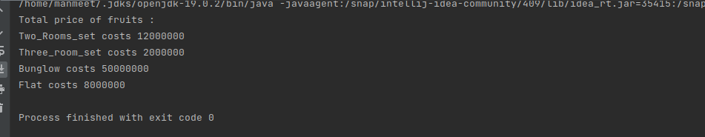

2) Create a User class with fields: firstname, lastname, age, phonenumber. Write a program which accepts values of user fields from commandline, create object and **append** that to a text file. After every user creation the program should prompt: "Do you want to continue creating users? (Type QUIT to exit)" and keep on accepting values and writing to file unitl user quits.

OUTPUT 2:



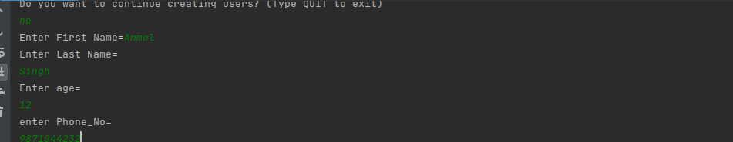

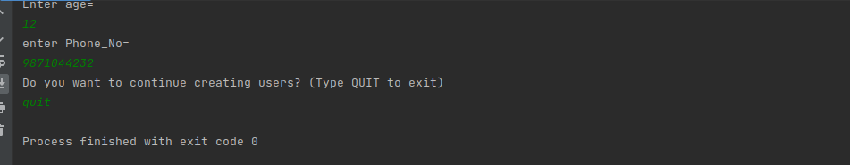

3) Write a program to count number of occurrences of a word in a file. The file name and word should be supplied through commandline.

OUTPUT 3:

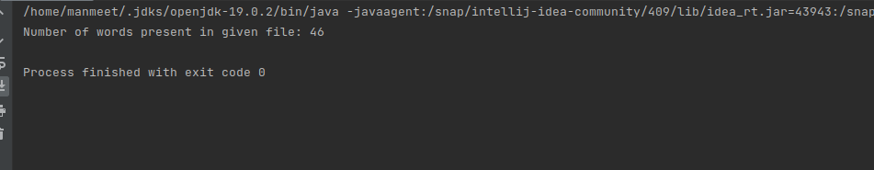

4) Write a program to show application of Factory Design Pattern.

OUTPUT 4:

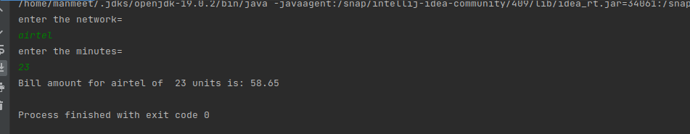

5) Write a program to show application of Singleton Design Pattern.

OUTPUT 5:

